Log in at <https://welcome.oda.sas.com/>

with z824116 and st72@SAS.

Then launch SAS Studio.

Basically you are working on a UNIX server with SAS in your own home directory.

right-clicking on “Files(Home)” shows you the filepath

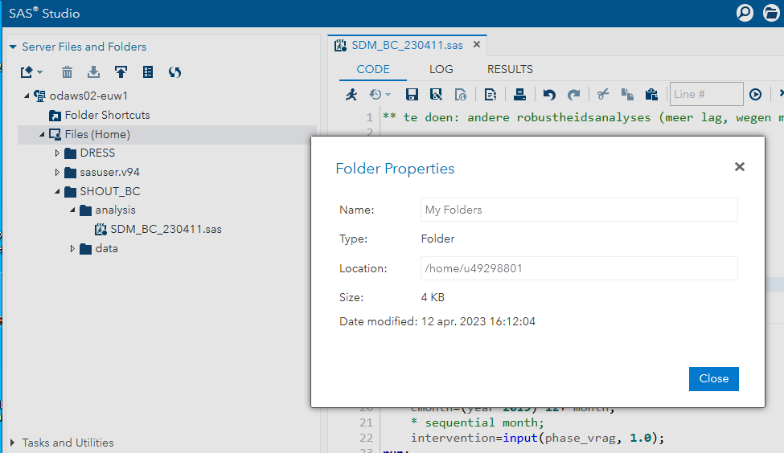

this file path can be used to save output (pdf, rtf) files with ods , to save figures, and export datasets to excel with proc export.

Uploading and downloading files (downloading after selecting the file) from the folder structure via:

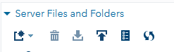

This way sas datasets or other data sources can be uploaded.

Library names can be assigned using the most left symbol (the file cabinet):

